

DEPARTMENT OF CYBER SECURITY

STUDENT NAME: TALAHA FAROOQ
REG # 232123
SECTION: BSCYSev-V-A
SEMESTER PROJECT – 2 - Mindmap
COURSE: ETHICAL HACKING & DEFENSE
SUBMISSION DUE DATE: 19/10/2025
SUBMITTED ON: 19/10/2025
Program link: bugcrowd.com/engagements/atlassian

Diagrammatical Overview:
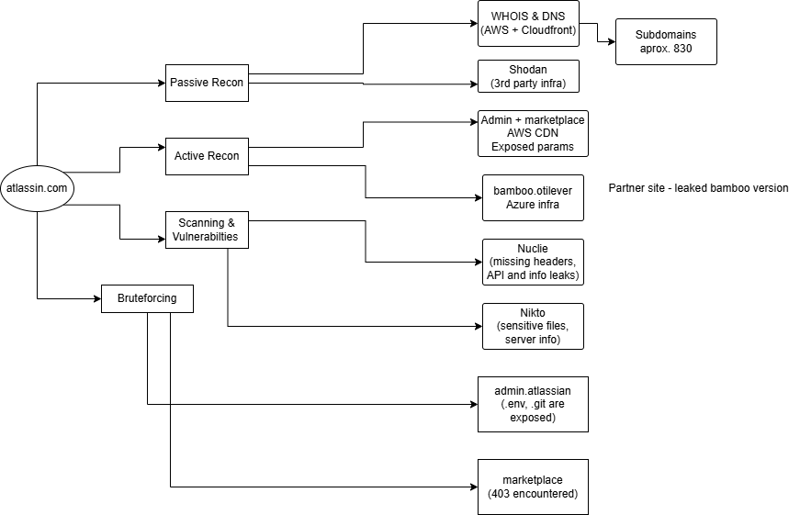
I started the engagement by conducting passive reconnaissance of the publicly available assets of Atlassian. WHOIS and DNS enumeration soon showed that Atlassian is extremely dependent on Amazon CloudFront and AWS Route 53 to provide DNS and content delivery services. This configuration aids in making option servers and enhances accessibility in regions. This was confirmed when Shodan results displayed CloudFront fingerprints within subdomains and some extra third-party hosting can also be seen, especially in bamboo.otiselevator.com, which belongs to the infrastructure of a partner being hosted on Microsoft Azure.
The most useful steps were subdomain enumeration. The tools such as subfinder helped me reveal more than 830 unique subdomains most of which were named according to a rule such as .saas.atlassian.com, indicating a high number of enterprise deployment environments. Others were evidently internal or dev-stage, which indicated possible points of flaw within logic and old-fashioned services.
During active recon:
- Both marketplace.atlassian.com and admin.atlassian.com are also resolved to the AWS CloudFront nodes and conceal their real sources.
- This was supported by latency checks and traceroutes and used Amazon infrastructure to route through.
- The example of Bamboo with Otis Elevator was more publicly available, it was not protected by a CDN, and displayed version information (Atlassian Bamboo 9.2.18).
Nuclei and Nikto scans had several soft spots. Lack of security headers was uniform amongst targets-- Content-Security-Policy, Permissions-Policy and Referrer-Policy were common in their absence. Two API keys were hardcoded in responses to the marketplace subdomain in the form of JavaScript code. Although they could be test tokens, they still signify bad treatment of secrets.
The finding of directory brute-forcing was among the more important ones. On admin.atlassian.com, it was possible to find files:
- .env
- .bashrc
- .git/config
were immediately available as HTTP 200 OK responses, which is unusual and possibly unsafe. These files tend to include credentials, paths or configuration secrets. On the marketplace side, a large number of these paths replied with 403 Forbidden, implying that they are probably there, though restricted by access - also useful in future fuzzing or timing based testing.
The admin domain was a goldmine in terms of parameter discovery. Many dozens of parameters were uncovered, such as the user id, the orgid, workspaceAri, or different filters and search terms. These are good candidates of IDOR, privilege escalation, or bypasses. Although marketplace.atlassian.com contained fewer dynamic routes, it nonetheless contained common search and tracking options (query, utm source, etc.), which could be reviewed with regards to client-side exploits such as reflected XSS or open redirects.
Overall Analysis:
- Atlassian’s main infra is well-distributed and masked via CloudFront, but still leaks sensitive metadata and files under certain subdomains.
- Missing headers and inconsistent cookie flags show room for improvement in browser-side protection.
- Exposed files on admin.atlassian.com and leaked API keys on marketplace could be pivot points for deeper exploitation.
- The parameter attack surface is wide and ideal for manual testing of authorization issues or injection scenarios.

